Fertilizer Recommendation System - Project Report

Executive Summary
This project develops a digital fertilizer recommendation system for farmers in Bangladesh, helping them use the correct amount of fertilizers for their crops. It is a web-based application that provides personalized fertilizer recommendations based on user's location, field details, and soil test reports.

Problem Statement
Farmers in Bangladesh often struggle with insufficient knowledge and resources to use the right type and quantity of fertilizers, leading to reduced yields and soil health deterioration. The lack of a scientific approach to fertilizer recommendation exacerbates this problem.

Solution Approach

Data Collection and Processing
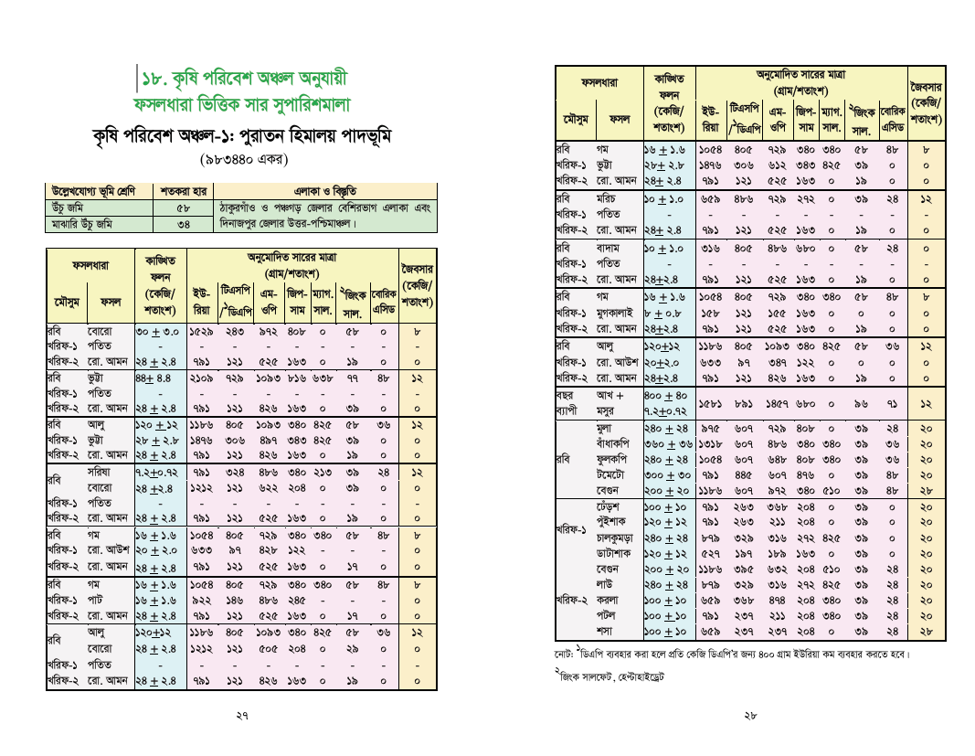
- Collected crop, season, and region-based fertilizer recommendation data from local agricultural databases.
- Implemented conversion system from Bengali numerals to English numerals.
- Created separate recommendations for different seasons (Rabi, Kharif-1, Kharif-2) and year-round crops.

Technology Stack
Backend: Python Flask Framework
Frontend: HTML5, CSS3, JavaScript
Database: PostgreSQL

Key Features
- User-friendly Bengali interface
- Location and field-based data loading (Data took from page 27)
- Soil test report input facility
- Nutrient calculation using BRAC formula (Took from page 105)
- Responsive design working on both mobile and desktop devices

Important Code Highlights
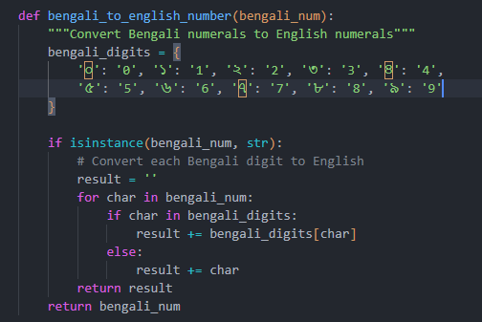
- Bengali Number Conversion (database.py)

This function converts Bengali numerals to English numerals, which is crucial for proper data storage and calculations in the database

- BRAC Formula Implementation (app.py)
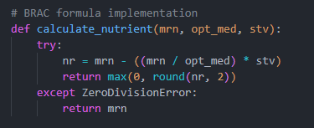

This function calculates nutrient requirements based on soil test values using the formula recommended by BRAC.

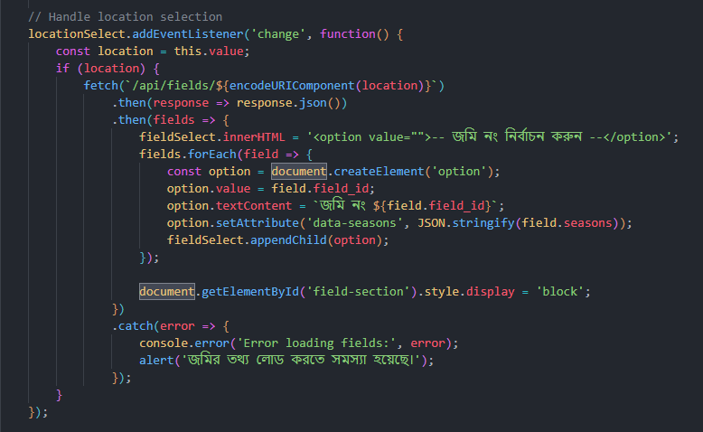
- Dynamic Field Loading (script.js)

This code uses AJAX to dynamically load field lists based on the user's selected location.

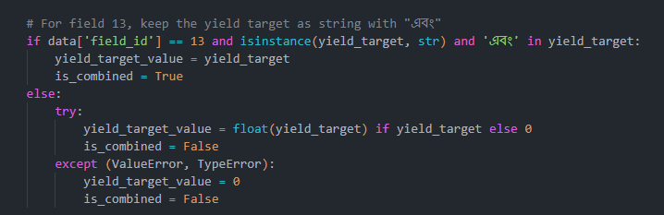
4. Special Case Handling(app.py)

Data Model and Database Design
The project uses PostgreSQL database to store data in the following structure:
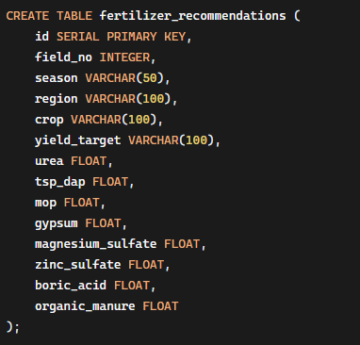

Challenges and Solutions
- Bengali Data Processing: Created custom functions for processing Bengali numbers and text
- Multiple Crop Management: Applied custom logic for special cases
- Real-time Calculation: Ensured efficient calculation on both client and server sides
- User Experience: Provided intuitive interface with step-by-step guidance

Results and Benefits
- Farmers can apply fertilizers scientifically
- Reduction in fertilizer costs and increase in crop yield
- Improvement in soil health
- Opportunity for digital agricultural advisory services

Future Development Areas
- Mobile application development
- Expanded crop and region coverage
- Integration of real-time market prices and weather information
- More accurate predictions using machine learning models

Conclusion
This project represents a shining example of data science application in Bangladesh's agricultural sector. It provides an effective solution by combining local needs with technology. The skills and experience gained from this project demonstrate my capability as a Data Science Trainee.

